Repeater - L 1 Relay
Bridge - L2 Relay
Router - L3 Relay

Differentiate between hub and switch.
a.) Hub is a layer 1 device while Switch is layer 2 device.
b.) Hub works on single collision and single broadcast domain while switch works on per port collision and single broadcast domain
What are 10Base2, 10Base5 and 10BaseT Ethernet LANs?
10Base2 is Ethernet run over RG58 coax. The 10 = 10Mbps. The 2 = 200 meters maximum segment length between repeaters. This stuff died out long ago.
10Base5 is Ethernet run over a large diameter coax (RG6 I think), we used to call this stuff a garden hose because that is what diameter the cable was. Again 10 = 10Mbps and 5 = 500 meters maximum segment length between repeaters. This died out before 10Base2 died.
10BaseT is Ethernet over twisted pair, which is the current medium used

Explain a.) Uni-casting, b.) Multicasting and c.) Broadcasting
a.) Uni-casting - Message is sent from a source to a single destination node.
b.) Multicasting - Message is sent from a source to some subsets of other nodes.
c.) Broadcasting - Message is sent from a source to all the nodes in the network

What are the advantages of IPv6 over IPv4?
the next generation IP, or IPv6 has some advantages over IPv4 that can be summarized as follows:
- Larger Address Space: An IPv6 address is 128 bytes long where IPv4 has 32-bit address only, this is a huge increase in the address space.
- Better Header Format: IPv6 uses a new header format which simplifies and speeds up the routing process because most of the options do not need to be checked by routers.
- New Options: IPv6 has new options to allow for additional functionalities.
- Allowance for extension: In IPv6 new technologies can easily embedded.
-Support For Resource Allocation: In IPv6, flow label has been added to enable the source to request special handling of the packet. This mechanism can be used to support traffic such as real-time audio and video.
-Support For More Security: The encryption and authentication options in IPv6 provide confidentiality and integrity of the packet.
Collision vs Broadcast Domain
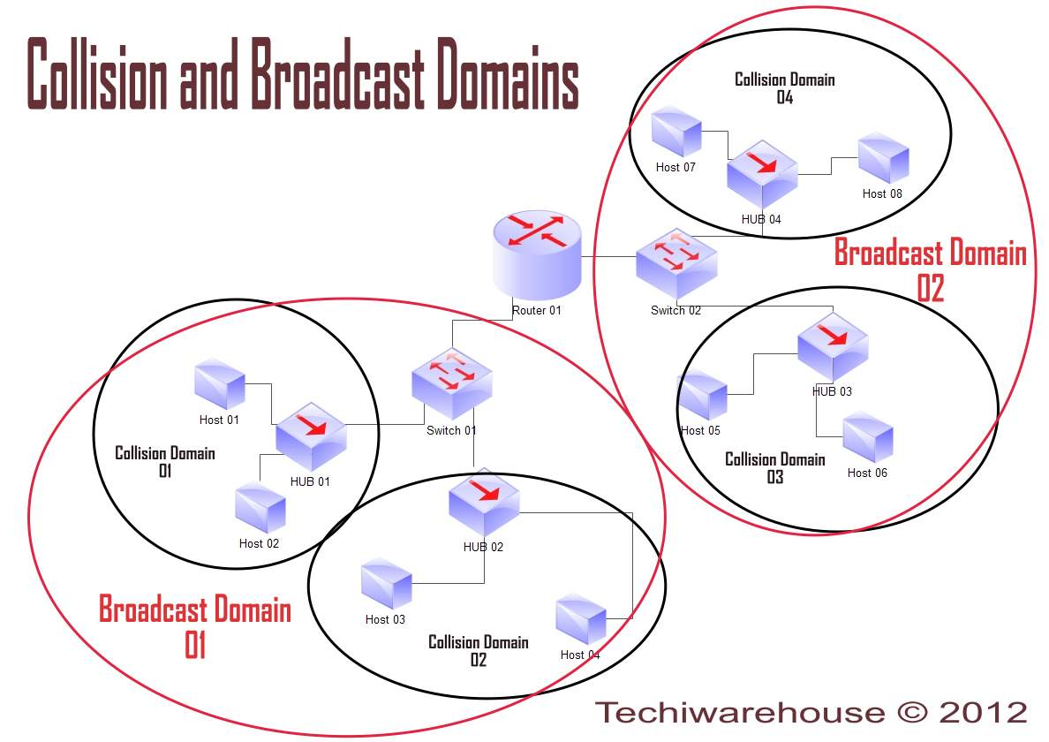

CSMA/CD
Collisions are resolved using carrier sense multiple access with collision detection (CSMA/CD) in which the competing packets are discarded and re-sent one at a time. This becomes a source of inefficiency in the network.

NO CSMA/CD on today's Ethernet
Modern switched Ethernet LANs are not CSMA/CD anymore. CSMA/CD was a technique that applied to 10mbit/sec and 100mbit/sec Ethernets that used hubs, not switches.
On modern switched Ethernets, you don't have a shared medium anymore. When you're plugged into a switch, the "collision domain" is only between you and your switch port. And if you're in full duplex mode, which is almost always true with switches, then you don't have any possibility of collision at all. If you can't have a collision, you'll never detect a collision, so you'll never have reason to transmit a jam signal.

Routers and other higher-layer devices form boundaries between broadcast domains.

Collision Domains
- layer 1 of the OSI model
- a hub is an entire collision domain since it forwards every bit it receives from one interface on every other interfaces

Broadcast Domains
- layer 2 of the OSI model
- a switch creates an entire broadcast domain (provided that there's only one VLAN) since broadcasts are a layer 2 concept (mac address related)

VLAN ( 802.1Q)
- Provide QoS by providing particular VLAN to priorities.
- Small ARP Broadcast Domain

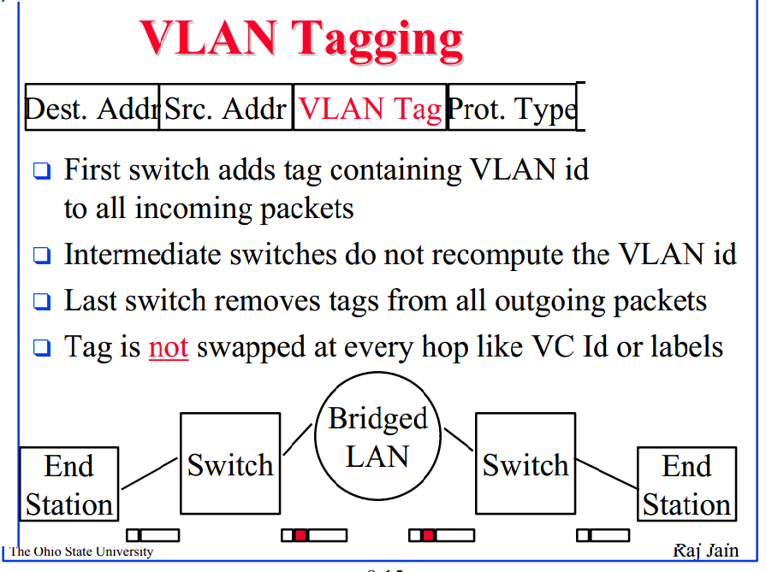

ACESS VLAN
Access ports belong to a single VLAN and do not provide any identifying marks on the frames that are passed between switches.

TRUNK VLAN
A trunk port is by default a member of all the VLANs that exist on the switch and carry traffic for all those VLANs between the switches

Untagged VLAN Port - Port pre-configured with a VLAN ID , VLAN packets coming out of this port is Untagged VLAN
i.e no VLAN tags .

Tagged VLAN Port - Packet retains Tag.

The 802.1Q tag contains 3 priority bits and 12 VLAN ID bits.Total 4096 VLAN IDs

- 4095 is discarded. 0 is user priority data.
- VLAN 0 packets should carry an 802.1p priority but otherwise should be handled as untagged packets

L2 Address is through MAC Address - ARP
L3 - IP (IPv4 and IPV6),ICMP
L4-Transporrt TCP or UDP

Segments | 4. Transport | Reliable delivery of packets between points on a network.
Packet/Datagram | 3. Network | Addressing, routing and (not necessarily reliable) delivery of datagrams between points on a network.
Bit/Frame | 2. Data link | A reliable direct point-to-point data connection.
Bit | 1. Physical | A (not necessarily reliable) direct point-to-point data connection.

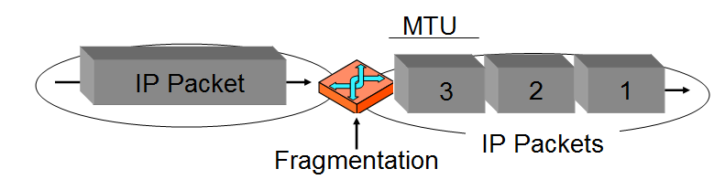

IP Fragmentation -MTU / H/w Limit / Flags -More Fragment ,Dont Fragment,
TCP Segmentation - MSS ( Max segment Size) /Software /No special Flags

IP Functions: End to End deliver of Packets

TCP Functions:
Sequence No & ACK -For complete message transfer
Flow control - Sliding Window

IP is for delivery of single packet
TCP is for delivery in Application in correct order

TCP Does Fragmentation due to MTU Restriction of Ethernet 1500

TCP | UDP
Reliable –ACK | Non-Reliable -NO ACK
Sequence No | NO order- No sequence No
 | RTP,DNS,DHCP,TFTP
Heavy | Lightweight
Streams- multiple packet per read call | Datagram -One packet is complete

UDP -TFTP may internally use sequence no in data to find sequence.

FTP - 21 Command , 20 Data TCP port

L4 -Segment ( TCP/UDP Segment)
L3- Packet ( IP Packet)
L2- Frame ( Ethernet Frame)
L1- 0& 1

MSS
During SYN Packet Exchange in TCP , system establishes MSS.

TCP/UDP - Only adds Port information in Data
IP - Add IP Address on Top of TCP
Ethernet - Add MAC on Top IP

MSS :
- TCP Segmentation ,occurs at source , if data do not fit in packet,
- Done at S/w Level.
- During SYN Packet Exchange in TCP , system establishes MSS.
- Reducing MSS prevents MTU fragmentation
MTU: Largest IP Packet a network will accept
- IP Fragmentation occurs after packet is created in between source
and destination
- Fragmentation occurs at intermediate devices

IP Packet

Figure of IP Packet???

Don't Fragment Flag - No IP fragmentation.
More fragment -Offset to see count fragments
TTL - decrement at each router , Prevents loop.

LRO
Aggregate multiple TCP packed based on Sequence on.
Send few packets to host process , less overhead and less CPU Cycles

GSO
Generic segmentation offload
Outgoing packet
Eliminates need of TCP do to segmentation
MSS Value

TCP Flow control -Sliding windows
TCP Congestion control- Slow start ( Windows size 1 and then increase)

Transport Layer -TCP /UDP
IP Layer -ICMP/ARP/IP

LAST_IN- last packet Flag
IP_MP - more fragment
IP_OFFSET- Fragment offset

IP defragmentation
- List of fragmented skb and chained together.
- Internet layer process on destination host defragments, restoring the original packet

Segmentation vs Fragmentation
Same basic concept just depends on where it occurs. Segmentation occurs during the original creation of the packet when a set of data does not fit within the max segment size within a packet. The data is then split across packets.

Fragmentation typically occurs after the packet was created, en route from source to destination. The packet encounters an interface with an MTU that is smaller than that of the packet's size, and as such, if fragmentation is supported, the packet is cut up into smaller pieces. If fragmentation is not supported, the interface would typically send an ICMP message back to the source informing it of the MTU-mismatch(unless you've disabled that on said interface).

Fragmentation is usually performed at the hardware level, and when data is chopped into fragments, it is referred to as a frame. Fragmentation occurrs so that data can be transmitted across a connection without overwhelming the memory buffers on either side of the connection

Segmentation usually occurs fairly early in the communication process and it is almost always software that performs the segmentation process. The segmentation process is performed prior to transfer of data across a network or before storage on a peripheral device. Segmentation is necessary because today's communication systems use what is called packetizedcommunication.

TCP is designed to restrict the size of the segments it sends to a certain maximum limit, to cut down on the likelihood that segments will need to be fragmented for transmission at the IP level

Scatter/Gather I/O
In computing, vectored I/O, also known as scatter/gather I/O, is a method of input and output by which a single procedure-call
sequentially writes data from multiple buffers to a single data stream or reads data from a data stream to multiple buffers.
The buffers are given in a vector of buffers. Scatter/gather refers to the process of gathering data from, or scattering data into,
the given set of buffers
- Concatenating output: An application that wants to write non-sequentially placed data in memory can do so in one vectored I/O operation. For example, writing a fixed-size header and its associated payload data that are placed non-sequentially in memory can be done by a single vectored I/O operation without first concatenating the header and the payload to another buffer
- Efficiency: One vectored I/O read or write can replace many ordinary reads or writes, and thus save on the overhead involved in syscalls

What is the purpose of TCP and IP ?Difference between Them?
MSS vs MTU
TCP vs IP segmentation/Fragmentation
TCP flow control and congestion control

QDISC
Sandwiched between the IP stack and the driver queue is the queueing discipline (QDisc) layer (see Figure 1). This layer implements the traffic management capabilities of the Linux kernel which include traffic classification, prioritization and rate shaping
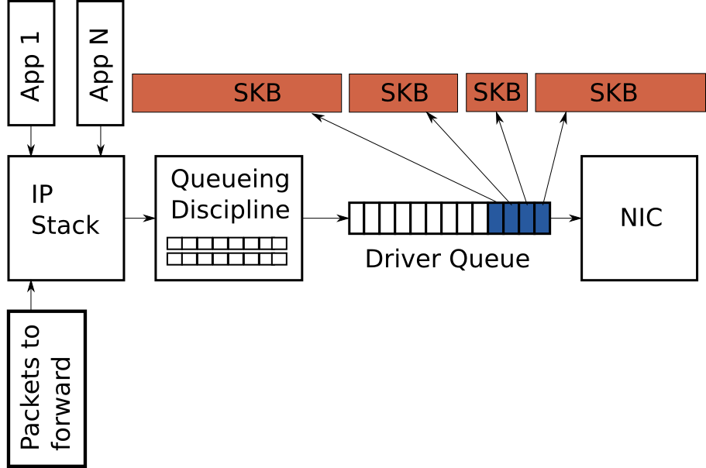

Router
Broadcast are discarded by Router e.g ARP Pakets
MAC address gets changes in router, needed for routing.

IPv4 - ARP
IPv6- NDP (Neighbor discovery protocol)

ICMP used for Ping and Router Advertisement( Router advertising its Interface IP)

RTP
Sequence No. -Packet loss
Timestamp-Jitter
SSRC
CSRC

IPv6 Address
1.Unicast
2.Anycast-Local balancer etc,Single address to multiple nodes ,If 3 systesm are acting as Load balancer , Nearest node gets the Packet.

3.Multicast Address

Ipv4 Link local address- 169.254.0.0
ipv6 Local Address - FE80::
loopback address ::1 or 0:0:0:0:0:1

Eliminating NAT Problem
1.IPv6
2.uPnP
3.TURN
4.STUN

MSS/MTU
--------
The absolute limitation on TCP packet size is 64K (65535 bytes),
The MTU (Maximum Transmission Unit) for Ethernet, for instance, is 1500 bytes
The default TCP Maximum Segment Size is 536.[2] Where a host wishes to set the maximum segment size to a value other than the default,
the maximum segment size is specified as a TCP option, initially in the TCP SYN packet during the TCP handshake

Delayed ACK- ack for 2 or more Packets or sending ACK for last packet.

Jumbo Frame-Ethernet frame of more than 1500(MTU) typically 9000.

LRO
---
IP header in LRO is recalculated.
RX->if LRO ->lro_receive_skb
if NAPI->netif_recieve_skb.

Changes for LRO
1.Send ack for Last packet
2.Calculate IP Checksum
3.Timestamp of last packet
4.TCP Checksum

combing - same connection, timestamp, high priority immediately sent.
rx /tx checksum at network -RX checksum offloaded automatically when GRO enabled??

iptables = userspace;
netfilter = kernelspace

1. On the VLAN aware bridge, a untagged packet received on a port for which VLAN is configured
What happens?
[ANS] Guess -- It is dropped, since port is configured to receive only tagged packets (??).. Question is not clear whether port is ACCESS port or TRUNK port. If it is TRUNK port, it receives packet... Not sure/clear about this..

NET_IP_ALIGN
Since an ethernet header is 14 bytes network drivers often end up with the IP header at an unaligned offset. The IP header can be aligned by shifting the start of the packet by 2 bytes. Drivers should do this with:

skb_reserve(NET_IP_ALIGN);

The downside to this alignment of the IP header is that the DMA is now unaligned. On some architectures the cost of an unaligned DMA is high and this cost outweighs the gains made by aligning the IP header.

